A Review / Preview of Simple Graphics Using Python / Turtle

# Introduction

We plan to present a series of graphic examples demonstrating Python and its turtle module. We plan to use these examples, individually as review at the tail end of our sessions in Introduction to Programing Using Python. But we see that they can, as a set, serve as well a review/preview of python. Where you know the python and turtle covered, you can review and think of additional ideas you might use. Where your knowledge of python lags the presentation, you can observe and recognize the features presented.

# Operation

Before presentation download each python file in to a place easy to access. Open IDLE to prepare for running programs. To aid quick access, you might want to open each file once.

At the beginning of each section, Open the associated python file**. Save As** to new name *file_name*_my.py. This is to provide you a file which you may "play with" without modifying the original.

# Loops and turtle - starry_night.py

Simple python plus a bit of turtle

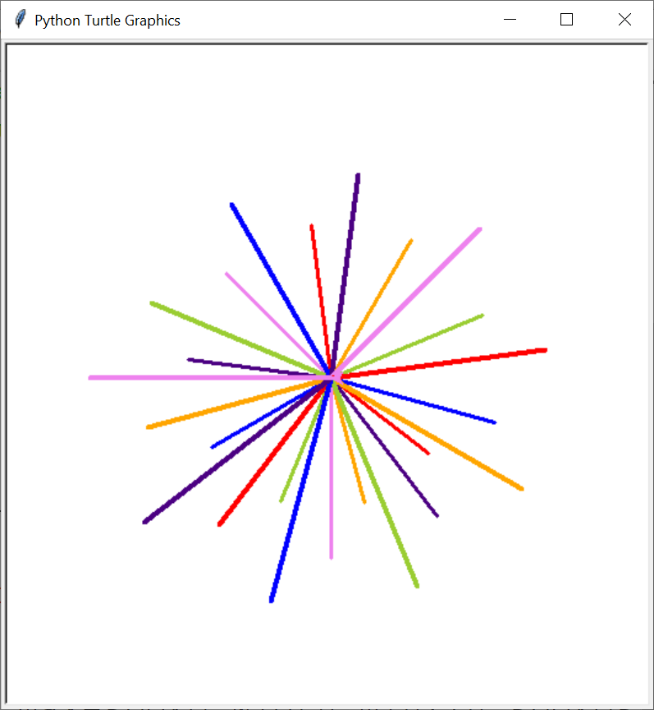

# Functions, random - shapes_around.py

Functions, keywords, defaults

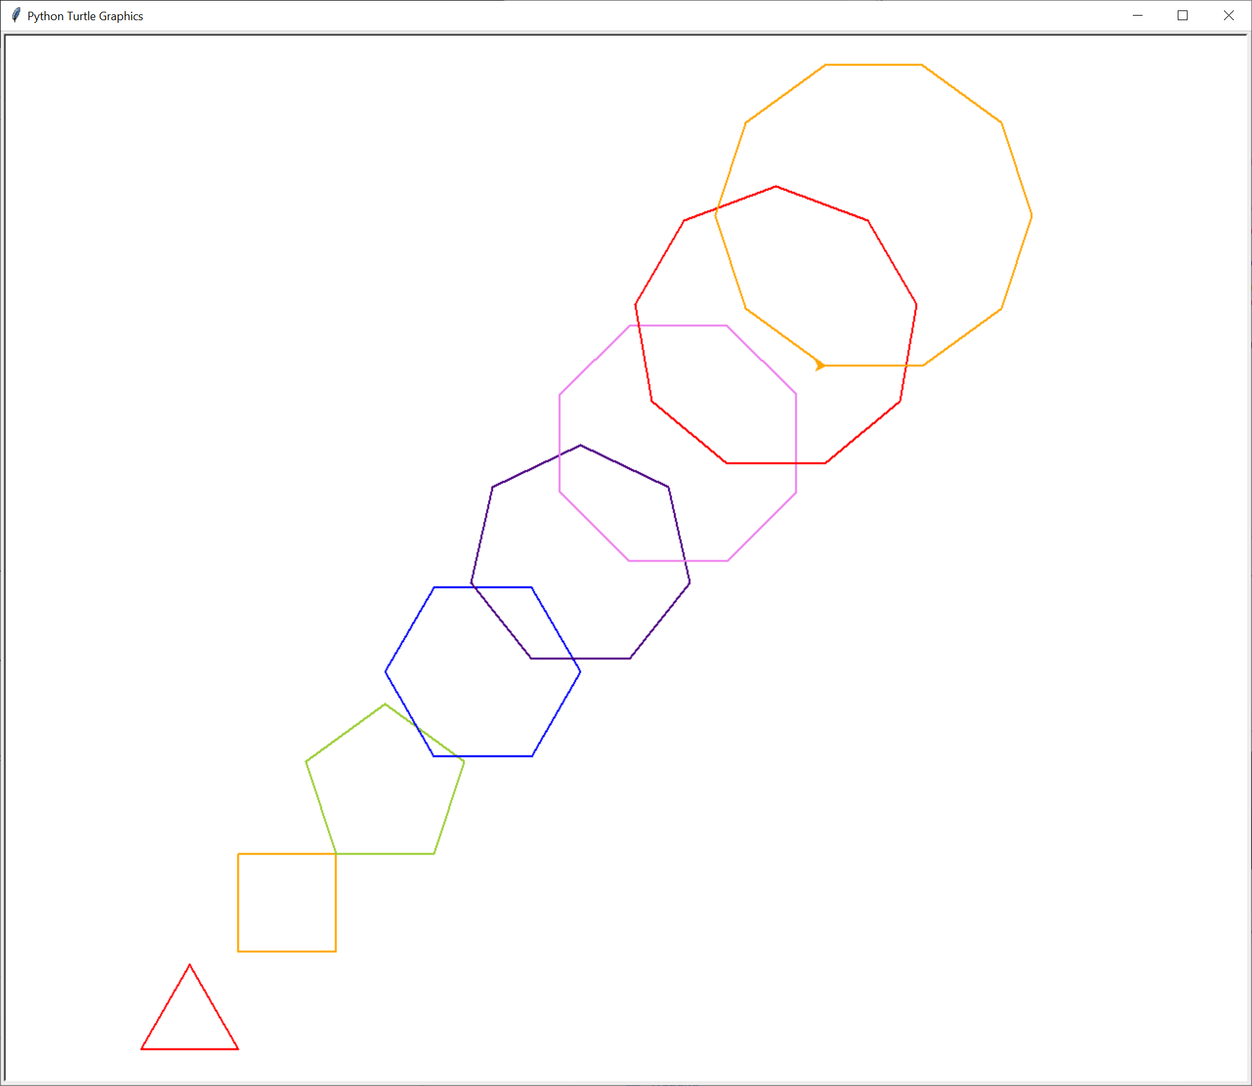

# Functions working together - bouncing_balls.py

Functions dividing up the task

Turtle event driven action

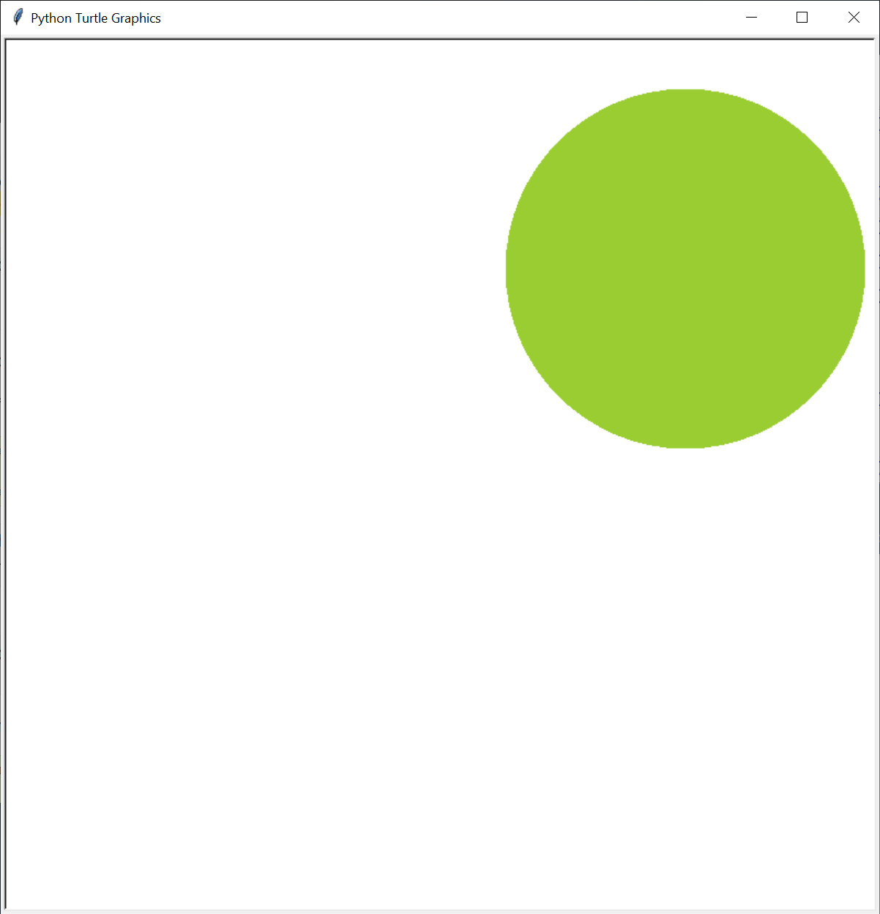

# Dictionary as an object - fireworks.py

Dictionary to hold information for each object

Turtle – more events

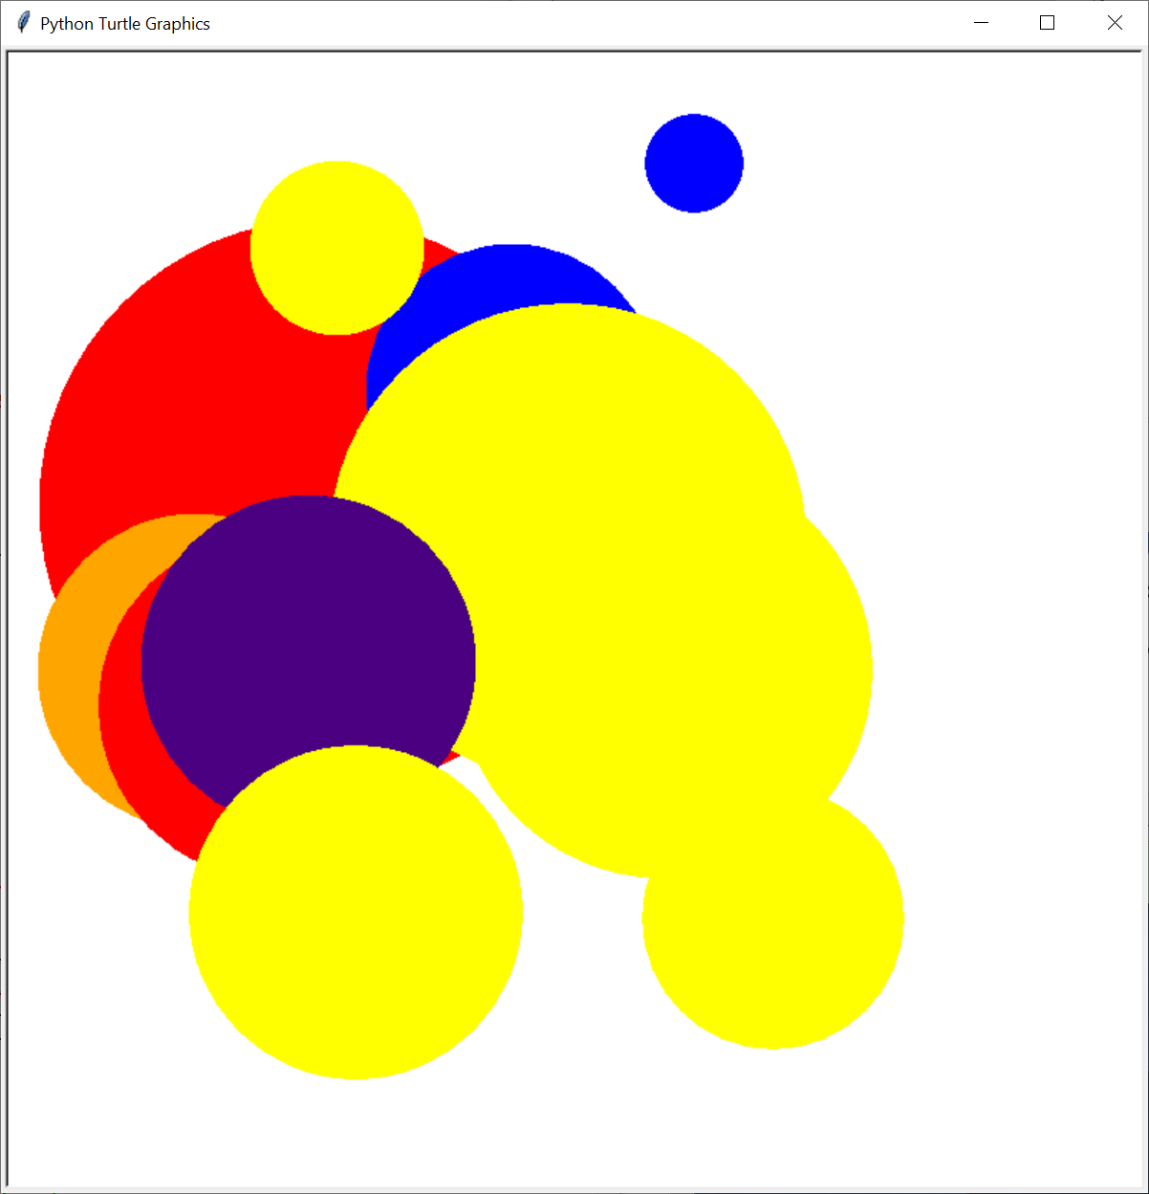

# Classes - square_lattice.py

Classes to build a system

Turtle – more events

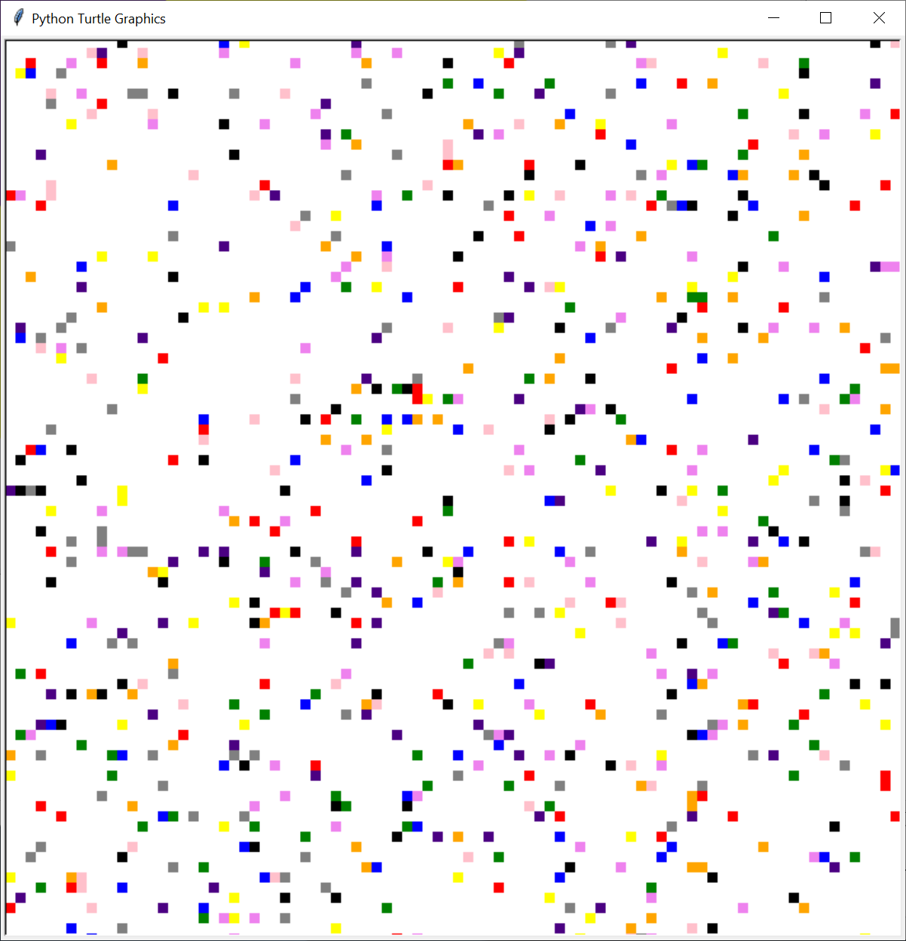

# Classes in separate file- square_lattice_varied.py

Turtle – more events

